**CSA1086 - Software Engineering**

GitHub branching and merge

1. Create a New Branch feature-login

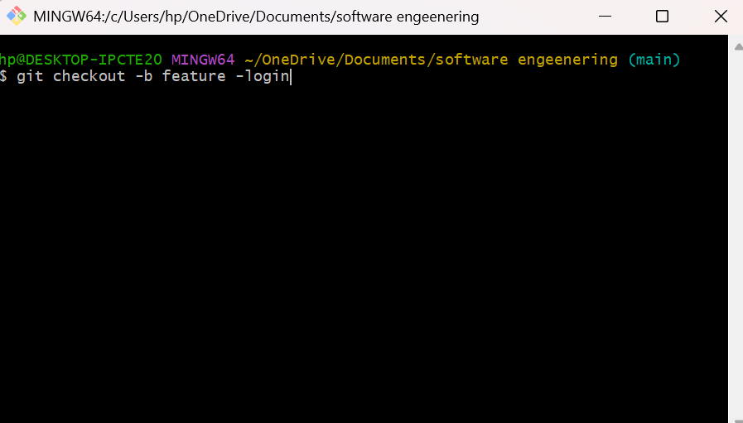

1. Create a login.py File with a Simple Login Function

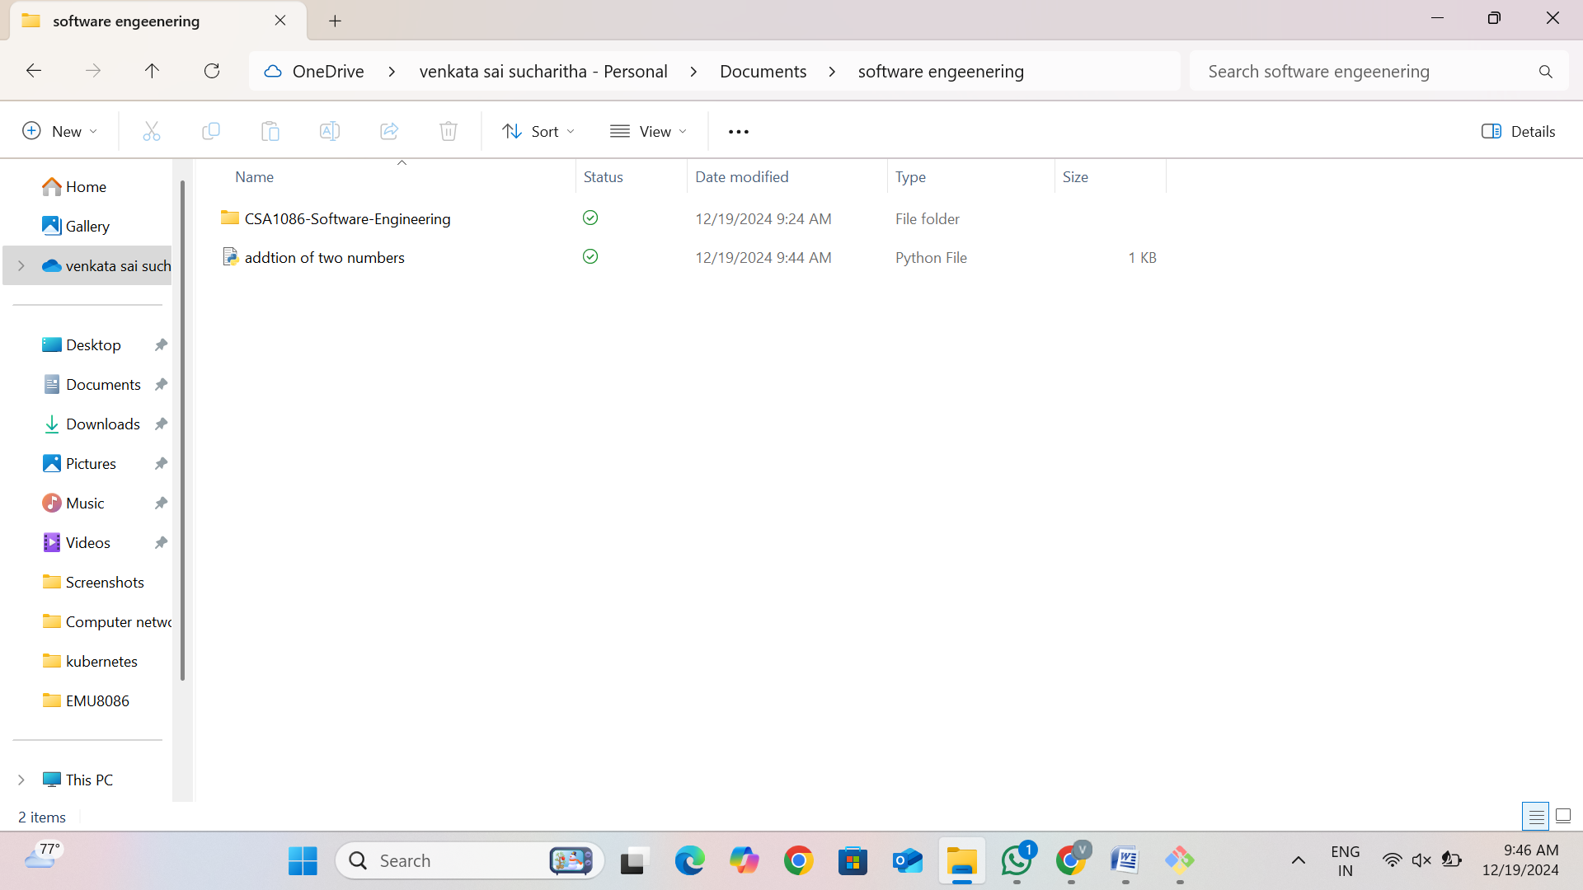

1. Commit the Changes

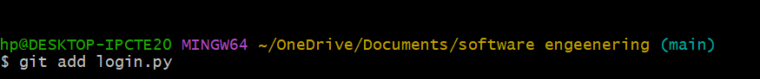



1. Push the Changes to GitHub



1. Create a Pull Request (PR) on GitHub
2. Merge the Pull Request